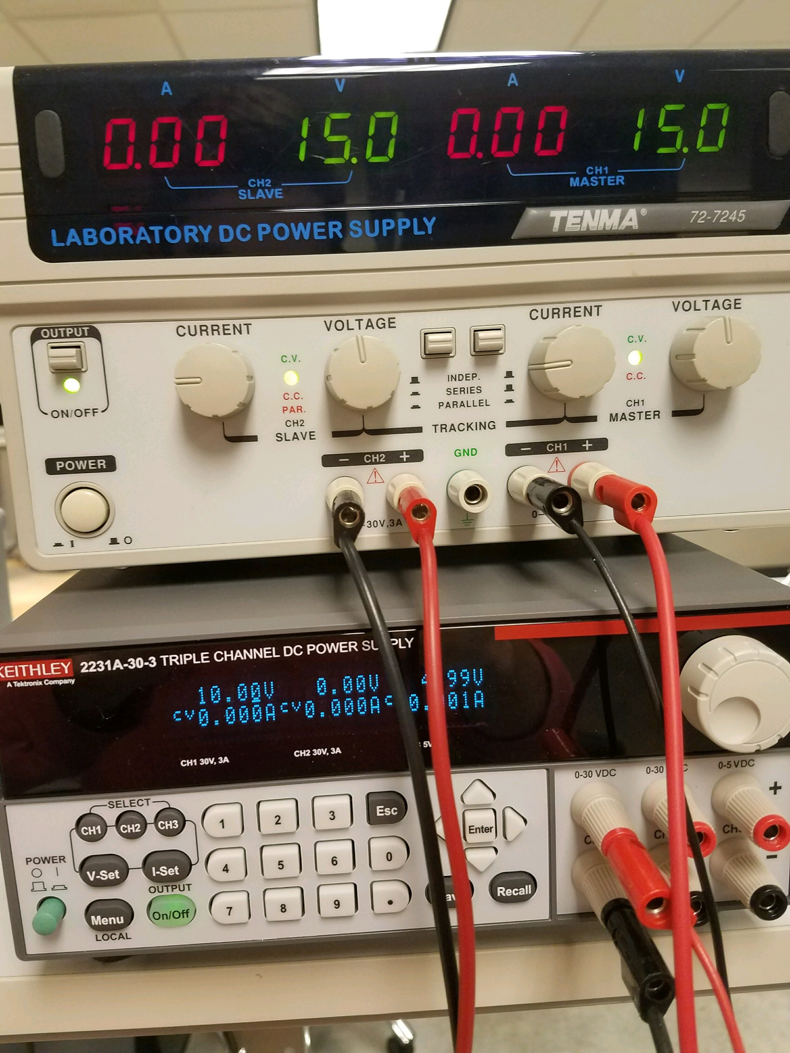

Figure 4: 10V supplied to circuit and +/- 15V supplied to each op amp

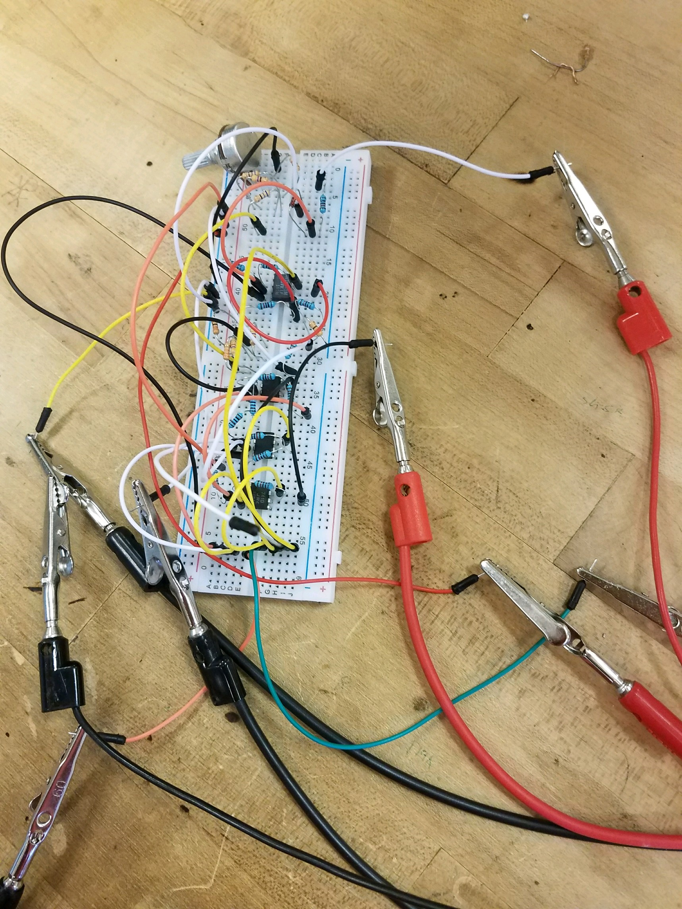

Figure 5: Circuit designed on breadboard

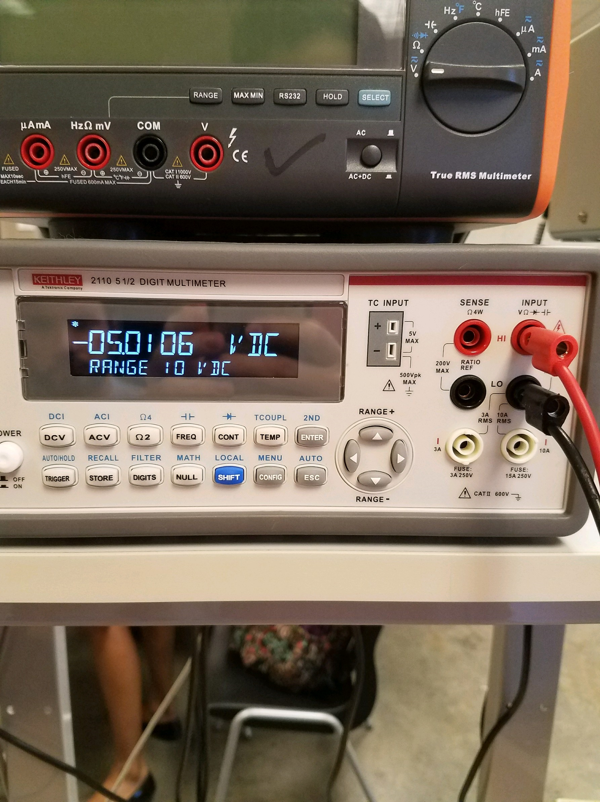

Figure 7: Negative output of breadboard experiment

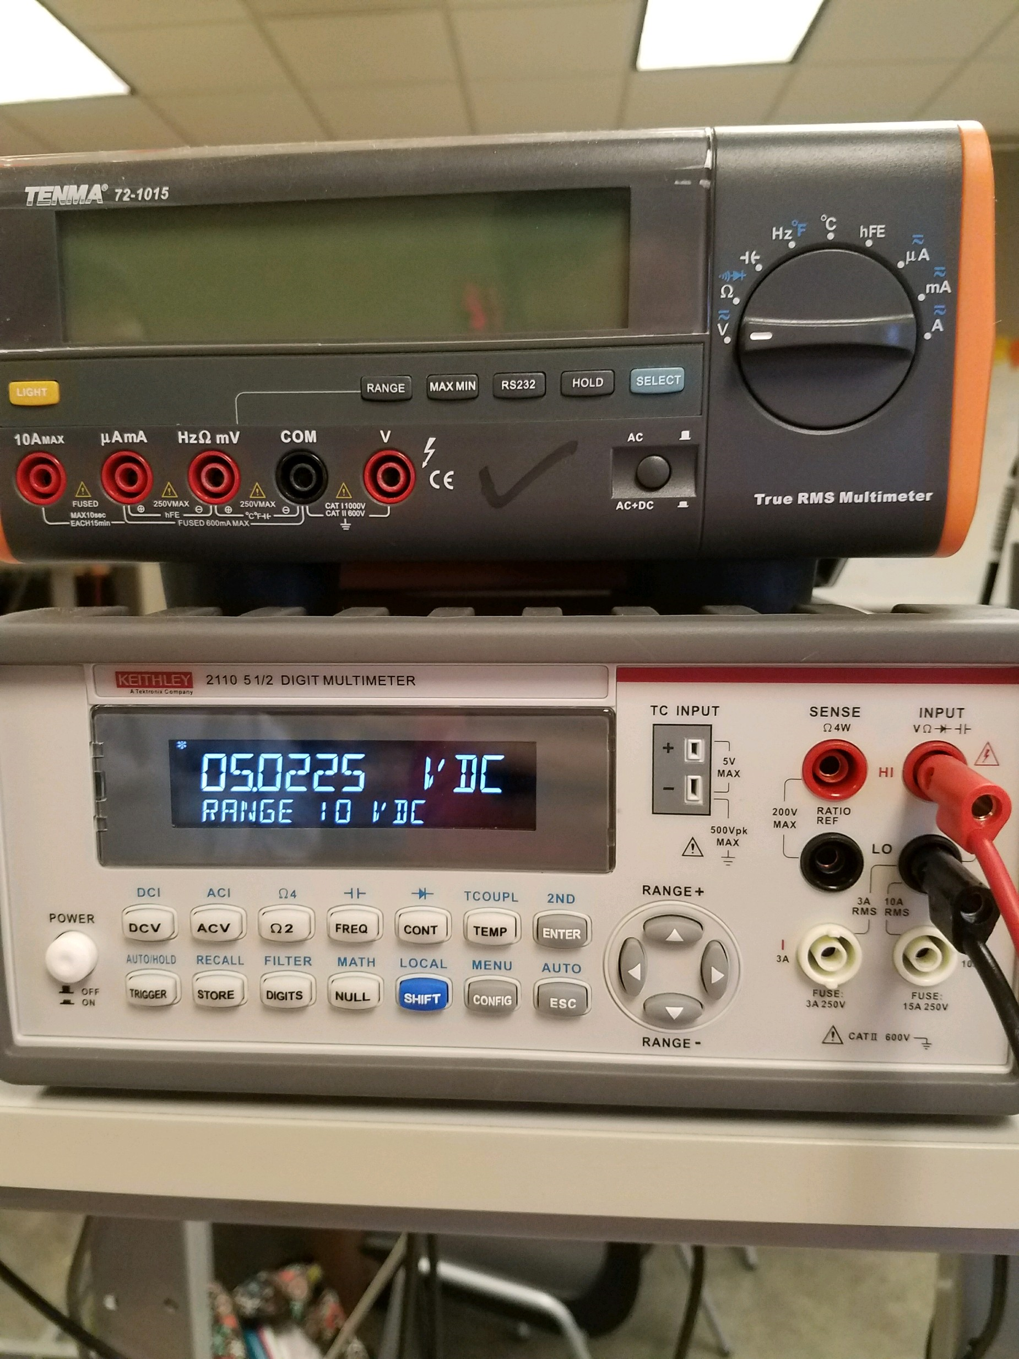

Figure 8: Positive output of breadboard experiment